UNIT-IV
UNIT-IV
Cloud Service Models: Infrastructure as service, characteristics of IaaS, Suitability of IaaS, pros and cons of IaaS, summary of IaaS providers, Platform as a Service with examples of Amazon DynamoDB, characteristics of PaaS, Suitability of PaaS, pros and cons of PaaS, summary of PaaS providers, software as a service, characteristics of SaaS, Suitability of SaaS, summary of SaaS providers.

What is a Cloud Service Models?
Cloud service models refer to the different ways cloud computing services are delivered and consumed. These models provide various levels of abstraction, management, and responsibility between the service provider and the user. The three primary cloud service models are
The National Institute of Standards and Technology (NIST) defines three basic service models, namely, IaaS, PaaS, and SaaS, as shown in Figure
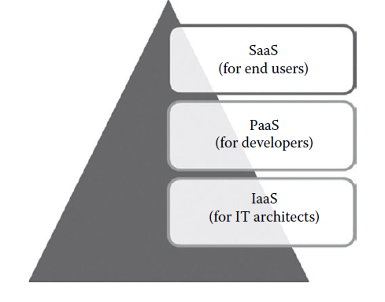
- Infrastructure as a Service (IaaS)
- Platform as a Service (PaaS), and
- Software as a Service (SaaS).
Each model offers a different set of capabilities and responsibilities for users and providers.
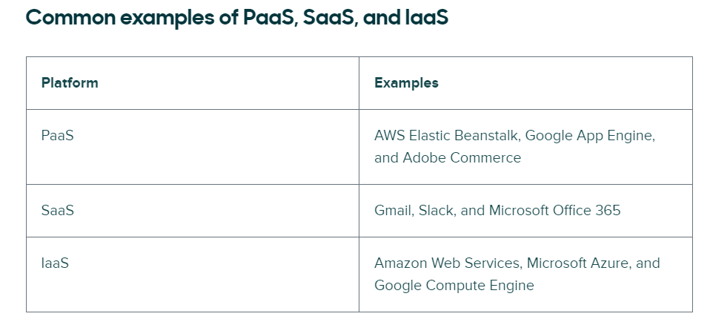
Infrastructure as service (IaaS)
Infrastructure as a Service (IaaS) is a cloud computing model that provides virtualized computing resources over the internet. In simpler terms, it offers virtualized computing infrastructure that can be rented out and accessed on-demand. This infrastructure includes servers, storage, networking, and other fundamental computing resources, allowing users to build and manage their own IT platforms without having to invest in physical hardware.
Key Components of IaaS:
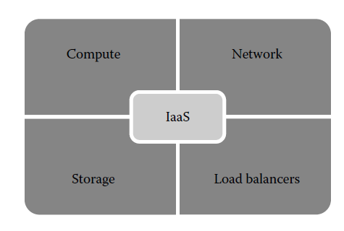
1. Compute (The Processing Power)
Compute resources represent the "CPU and RAM" of the cloud. In IaaS, physical servers are partitioned into Virtual Machines (VMs) using a Hypervisor. These VMs act like independent computers with their own Operating Systems (Windows/Linux). Users can scale these resources "Vertically" (making a single VM more powerful) or "Horizontally" (adding more VMs) to handle intense processing tasks without ever touching a physical chip.
Example: A software company developing a new AI tool requires massive processing power for one week to "train" their model. Instead of buying expensive hardware, they rent 100 High-Performance Compute Instances. Once the training is complete, they delete the instances, saving thousands of dollars in hardware costs.
2. Storage (The Data Repository)
IaaS provides virtualized storage that is much more flexible than a traditional hard drive. It is designed to be highly durable, meaning data is automatically replicated (copied) across multiple geographic locations to prevent loss. It supports Block Storage (for high-speed database performance), Object Storage (for massive, unstructured files like videos), and File Storage (for shared access across multiple users).
Example: A global hospital network uses Object Storage to keep millions of patient X-rays. Because the storage is "Elastic," the hospital never runs out of space as they add new records. If one data center fails due to a power outage, the records remain safe and accessible from a backup location.
3. Networking (The Connectivity Layer)
Networking in IaaS is "Software-Defined," meaning you build your network using code or a dashboard rather than physical cables. It allows users to create a Virtual Private Cloud (VPC), which is a private "bubble" on the internet. Inside this bubble, you can create Subnets to organize traffic and Security Groups (Virtual Firewalls) to block unauthorized users from reaching sensitive data.
Example: A bank uses IaaS networking to separate its "Public Web Server" from its "Private Database." By setting up a Subnet with strict firewall rules, they ensure that customers can see the website, but no one from the internet can directly touch the database containing private account balances.
4. Security and Compliance (The Protection Framework)
Security in IaaS is a "Shared Responsibility." The provider secures the physical data center, while the user uses IaaS tools like Identity and Access Management (IAM) and Data Encryption to protect their files. Providers also undergo strict audits to provide Compliance Certifications (like HIPAA for health or PCI-DSS for credit cards), ensuring the infrastructure meets international legal standards.
Example: A small online retailer uses a cloud provider that is PCI-compliant. This means the retailer can tell its customers that their credit card data is being handled on a platform that meets the world’s highest security standards, which would be too expensive for the small retailer to achieve on their own.
5. Load Balancers (The Traffic Management)
A Load Balancer acts as a "Strategic Gatekeeper" for incoming web traffic. When millions of users visit a site at once, a single server would crash. The Load Balancer sits in front of the servers and "distributes" the workload evenly across a "Server Farm." If one server becomes unhealthy or slow, the Load Balancer automatically stops sending traffic to it and redirects users to a healthy server.
Example: During a major ticket sale for a concert, a website experiences a massive surge in traffic. The Load Balancer detects the surge and spreads the 500,000 users across 20 different servers. This prevents the website from "freezing" or crashing, ensuring a smooth experience for the fans.

Characteristics of IaaS

1. On-Demand Self-Service
You are in total control. You don't have to email a technician or wait for a "ticket" to be processed to get a new server. You use a dashboard or a line of code to get what you need instantly.
Example: A developer at a startup needs a database to test a new feature at 2:00 AM. Instead of waiting for the IT department to open on Monday, they log into the AWS console, click a few buttons, and have a database running in 5 minutes.
2. Scalability and Elasticity
This is the ability to grow or shrink based on how much work there is to do. Scalability is the capacity to grow; Elasticity is the automatic nature of that growth.
Example: An E-commerce website normally runs on 2 servers. On Black Friday, traffic jumps by 500%. The IaaS platform senses the "heat" and automatically adds 10 more servers. When the sale ends, it "snaps back" and deletes those 10 servers so the company stops paying for them.
3. Pay-Per-Use Pricing
You only pay for the minutes or hours your resources are actually turned on. It’s like a taxi meter—if the car isn't moving, the fare doesn't go up.
Example: A research lab runs a massive data simulation that requires 100 high-power computers. The simulation takes 4 hours. They pay only for those 400 "computer-hours" and then turn them off. They don't have to own the 100 computers.
4. Flexible Resource Allocation
You can "mix and match" your hardware. You can choose a server with a lot of "brain power" (CPU) but very little storage, or a server with massive storage but a small "brain."
Example: A video editing company chooses a VM with a powerful GPU (Graphics Card) for rendering movies, while their accounting department chooses a cheap, low-power VM just for spreadsheets.
5. Broad Network Access
The "Cloud" isn't a physical place you visit; it's a service you access through the internet. This means anyone with a login can use it from anywhere.
Example: A global team has developers in India, designers in London, and managers in New York. They all log into the same IaaS environment to build their app, seeing the exact same files and servers in real-time.
6. Resilience and Availability
IaaS providers have data centers all over the world. They copy your data to different buildings so that if one building fails, your system stays alive.
Example: A bank hosts its website in the cloud. A massive storm knocks out power to an entire city where a data center is located. Because of IaaS Resilience, the bank's website automatically stays online by running from a second data center 500 miles away.
7. Security and Compliance
Cloud providers handle the "big" security (guards at the door, encrypted hard drives). They also make sure the hardware meets legal standards (like healthcare or banking laws).
Example: A small medical clinic uses IaaS to store patient records. They don't have the budget to hire a 24/7 security team, but by using the cloud, they get the benefit of the multi-million dollar security systems that the provider (like Microsoft or Google) already has in place.
8. Managed Infrastructure (Support & Maintenance)
The provider takes care of the "dirty work." They handle the broken wires, the dusty fans, and the physical repairs of the servers.
Example: A company's server room used to get too hot, and the IT guy had to spend his weekends fixing the air conditioning. After moving to IaaS, the company closed the server room. Now, if a server breaks, the Cloud Provider replaces the hardware silently in the background while the company's app keeps running.

Suitability of IaaS
Infrastructure as a Service (IaaS) is suitable for a wide range of use cases and organizations, offering flexibility, scalability, and cost-efficiency. Here are detailed insights into the suitability of IaaS for various scenarios:
1. Startups and Small Businesses (Financial Agility)
Shifting from CapEx to OpEx.
Startups often lack the capital to build a private data center. IaaS allows them to treat IT infrastructure as a utility (like electricity). By using Pay-As-You-Go billing, they preserve cash flow and avoid "Technical Debt" from buying hardware that might become obsolete in two years.
Example: A fintech startup uses IaaS to launch a prototype. They spend only $100 on server costs during the first month. As they gain users, they scale their infrastructure instantly without needing a million-dollar loan for hardware.
2. Large Enterprises (Business Continuity)
Reliability and Speed.
For large corporations, "Downtime" equals millions in lost revenue. IaaS provides Disaster Recovery (DR) as a service, replicating data across "Availability Zones" to ensure 99.99% uptime. Furthermore, it speeds up the Time-to-Market by allowing developers to spin up "Sandbox" environments for testing in seconds.
Example: A global retail chain uses IaaS to host its backup systems. When a primary data center in one region fails due to a natural disaster, the IaaS platform automatically "fails over" to a secondary region, keeping the business operational.
3. Industries with Variable Demand (Elasticity)
Handling "Spiky" Workloads.
Some businesses have predictable or unpredictable surges in traffic. IaaS Auto-scaling features allow the infrastructure to grow or shrink in real-time. This prevents "Over-provisioning" (paying for idle servers) and "Under-provisioning" (crashing during high traffic).
Example: An Online Education Platform sees a 10x increase in users during final exam weeks. They use IaaS to scale up their compute power for those 14 days and then automatically scale back down once the exams are over to minimize costs.
4. Research, Big Data, and AI (Computational Power)
High-Performance Computing (HPC).
Modern research involves "Big Data" analytics and Machine Learning (ML) that require thousands of CPUs or GPUs. IaaS provides access to Supercomputing-level resources on-demand, which would be physically and financially impossible for most research teams to build locally.
Example: A pharmaceutical company uses IaaS to run "Molecular Modeling" for a new drug. They rent 1,000 high-memory virtual machines for 72 hours to process the data, achieving results in days that would take months on a standard office server.
5. Global and Distributed Teams (Accessibility)
Broad Network Access.
IaaS resources are hosted on the "Edge" of the internet. This means data and applications can be placed in data centers physically close to the users, reducing Latency (lag). It provides a centralized, secure "Single Source of Truth" for teams scattered across the globe.
Example: A multinational architectural firm hosts its heavy 3D-rendering software in the cloud. Architects in Dubai, London, and New York all log into the same high-performance environment, ensuring everyone is working on the most recent version of the project.
6. Compliance and Regulated Industries (Security Standards)
Governance and Risk Management.
Industries like Healthcare (HIPAA) and Finance (PCI-DSS) must follow strict laws. IaaS providers invest billions in Compliance Certifications. By using a certified IaaS provider, a business "inherits" those security controls, making it easier to pass legal audits.
Example: A digital health app stores sensitive patient records. By using a HIPAA-compliant IaaS provider, the app ensures that its data encryption and physical security meet federal laws without the company having to build a specialized secure facility themselves.
7. Modern IT Strategies (Hybrid & Multi-Cloud)
Optimization and Flexibility.
Many companies use a Hybrid Cloud model, keeping sensitive "Legacy Data" on-premises while moving their "Web Front-end" to the cloud. Others use Multi-Cloud (using AWS and Azure simultaneously) to avoid "Vendor Lock-in" and ensure that if one provider has an outage, the other stays up.
Example: A government agency keeps citizen ID data in a private, highly-secured local server but uses a public IaaS provider to host the "User Portal" where citizens log in, combining maximum security with high-speed accessibility.

Pros and Cons of IaaS:
Advantages (Pros) of IaaS
1. Scalability and Elasticity
The ability to match resource supply with demand.
IaaS offers Vertical Scaling (adding more power to a single machine) and Horizontal Scaling (adding more machines). Elasticity allows this to happen automatically through "Auto-scaling" groups, meaning the system grows during peak traffic and shrinks when idle.
Example: An online streaming service automatically adds more servers on a Friday night when millions of users start watching movies, then shuts them down on Monday morning to save money.
2. Cost Efficiency
Moving from CapEx (Capital) to OpEx (Operational) spending.
Businesses save money because they don't have to buy expensive physical hardware upfront. The Pay-as-you-go model means you only pay for what you use. Furthermore, it eliminates "Hardware Maintenance" costs like electricity, cooling, and physical security guards.
Example: A startup launches its website for $10/month using IaaS instead of buying a $2,000 physical server that might sit unused half the time.
3. Disaster Recovery and Business Continuity
High Availability and Data Protection.
IaaS providers use Geographic Redundancy, meaning they store your data in multiple physical locations (Regions). If one data center is destroyed by a fire, the system automatically "fails over" to another location, ensuring the business never stops.
Example: A bank stores its records in a "Multi-Region" setup. If a flood hits their primary data center in New York, their backup in Chicago takes over immediately without the customers noticing.
4. Security and Compliance
Enterprise-Grade Protection.
Cloud providers spend billions on security measures like advanced firewalls, Intrusion Detection Systems (IDS), and multi-layer encryption. They also maintain Compliance Certifications (like HIPAA or GDPR), which saves the customer from the complex work of meeting legal standards.
Example: A small healthcare clinic uses IaaS to store patient data, benefiting from the same high-level security systems used by the world's largest governments and banks.

Disadvantages (Cons) of IaaS
1. Complexity and Management Responsibility
The "Shared Responsibility" burden.
While the provider manages the hardware, the User is responsible for managing the Operating System, Middleware, Applications, and Data. This requires a highly skilled IT team that understands virtual networking and cloud security.
Example: If a company forgets to patch their "Virtual Machine's" Windows OS, they could get a virus. The cloud provider will not fix this; it is the company's job to manage their own software.
2. Dependence on Internet Connectivity
The "Offsite" Risk.
Since IaaS is accessed over the internet, a stable connection is mandatory. If the internet goes down, the business loses access to its infrastructure. Additionally, Network Latency (lag) can occur if the data center is located too far from the user.
Example: A manufacturing plant that relies on real-time cloud data may see its assembly line stop if its local ISP (Internet Provider) has an outage.
3. Vendor Lock-In
Difficulty of Migration.
Once a business builds its entire network using a specific provider’s proprietary tools (like AWS-specific databases), it becomes very difficult and expensive to move that data to a different provider like Azure or Google Cloud.
Example: A company wants to switch cloud providers to save money, but they realize it will cost them $50,000 in "Data Egress" fees just to move their files out of the first provider's system.
4. Unpredictable Costs
Billing Complexity.
Because billing is based on usage, a sudden spike in traffic or a mistake in configuration (like leaving an expensive test server running) can lead to a "Surprise Bill" at the end of the month.
Example: A developer accidentally leaves a high-powered "Supercomputer" instance running over a long holiday weekend, resulting in a $5,000 bill for a project that was supposed to cost $50.
Summary Of IaaS Providers
- There are many public and private IaaS providers in the market who provides infrastructure services to the end users. Table 5 provides the summary of popular infrastructure providers.
- In the table, the popular IaaS providers are classified based on the license, deployment model, and supported host OS, guest OS, and hypervisors. The end user may choose any IaaS provider that matches their needs.
- Generally, public IaaS consumers need not consider the host OS as it is maintained by the service provider.
- In managing the private cloud, the users should see the supported host OS. However, most of the private IaaS supports popular guest OS, fully depending on the hypervisor that the IaaS providers are supporting.
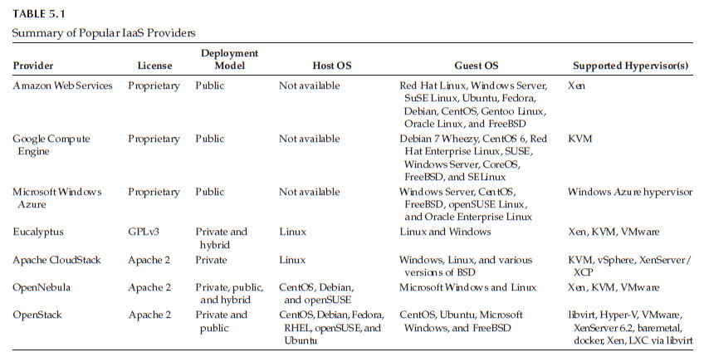
Infrastructure as a Service (IaaS) is a cloud computing service model that provides virtualized computing resources over the internet. Various IaaS providers offer a range of services and capabilities. Here is a summary of some of the leading IaaS providers:

Platform as a Service with examples of Amazon DynamoDB
Platform as a Service (PaaS) is a cloud computing model that provides a platform allowing customers to develop, run, and manage applications without the complexity of building and maintaining the underlying infrastructure. In the PaaS model, the cloud provider hosts the hardware, software, and development tools necessary for application development, deployment, and management, while users focus on building and deploying their applications.

Key Components of PaaS:
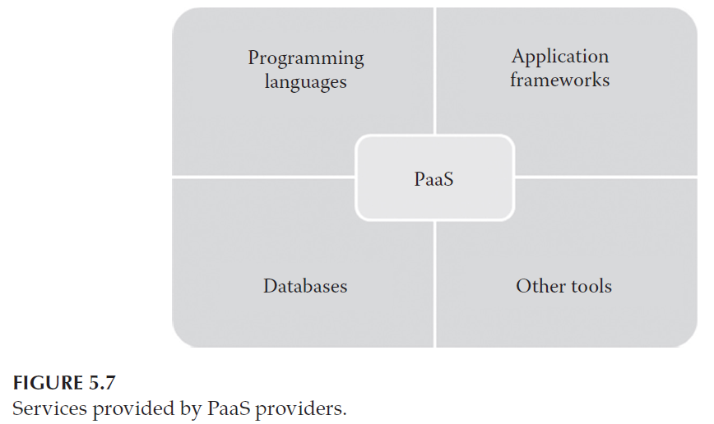
Key Components of PaaS
The "Platform" in PaaS is a pre-configured stack of software. Here is a breakdown of what that stack includes:
1. Programming Language Runtimes
PaaS providers offer "Runtime Environments" for various languages. A runtime is the engine that actually executes the code. In traditional IT, a developer spends hours installing compilers, setting environment variables, and managing versions. In PaaS, the environment is Pre-Configured.
Example: If a team is building an AI script in Python, they don't need to install Python 3.12 on a server. They simply select "Python" from the PaaS menu, and the platform provides a ready-to-use engine.
2. Application Development Frameworks
Frameworks are collections of "Ready-to-Use" code libraries that handle repetitive tasks ( like user login, data encryption, or connecting to a web server). PaaS vendors integrate these frameworks directly into the IDE to speed up development.
Example: Using the Django (Python) or Spring (Java) framework on a PaaS platform allows a developer to build a secure "Shopping Cart" feature by using pre-written templates instead of writing thousands of lines of code from scratch.
3. Integrated Databases (DBaaS)
Since almost every app needs to store data, PaaS provides Database as a Service. These are fully managed, meaning the provider handles the backup, security patching, and hardware scaling of the database.
Example: A mobile app developer connects their app to a MongoDB or Redis database provided by the PaaS. They don't need to worry about "Running out of space" because the platform automatically grows the database as more users sign up.
4. Specialized Development Tools
This component includes the "Software Factory" tools:
  - Debugger Tools: To find and fix code errors.
  - Source Control: To save different versions of the code (like Git).
  - Testing Suites: To automatically check if the app works on different devices.
Example: A developer uses a built-in Automated Tester to simulate 1,000 users hitting the app at once to see if it crashes before they officially launch it.

Characteristics of PaaS
PaaS is unique because it shifts the focus from "Managing Servers" to "Writing Code." Here are its defining traits:
1. All-in-One Development Environment
PaaS provides a "Unified Workspace." In one single screen (IDE), a developer can write code, test it for bugs, and deploy it to the live internet. This removes the need to switch between different software programs.
Example: A developer finishes a piece of code and clicks a single "Deploy" button. The PaaS automatically moves the code from the "Private Lab" to the "Live Website" in seconds.
2. Web-Based UI & Remote Access
Traditional development requires heavy software installed on a powerful laptop. PaaS is Browser-Based. This means a developer can log in from a simple Chromebook or tablet and have access to a world-class coding environment.
Example: A lead developer is traveling and realizes there is a bug. They log into the PaaS via a Web Browser at the airport, fix the code, and update the app without ever opening a laptop.
3. Built-in Scalability & Auto-Balancing
PaaS is "Cloud Native." It is designed to handle "Dynamic Loads." Unlike IaaS, where you might have to set up your own scaling rules, PaaS often handles Auto-scaling by default. It manages the "Platform" so the app never feels slow to the end-user.
Example: A news app goes viral. The PaaS detects the 500% increase in traffic and automatically allocates more memory and CPU to the app's runtime so the page doesn't go down.
4. Collaborative Lifecycle Management
Modern software is built by teams, not individuals. PaaS includes "Collaboration Hooks" that allow multiple people to work on the same line of code without overwriting each other's work. It also includes project management tools like task lists and communication logs.
Example: Two developers—one in New York and one in Singapore—are working on the same app. The PaaS keeps track of who changed what, ensuring that the "Singapore" updates don't break the "New York" features.
5. Offline Access & Synchronization
While PaaS is a "Cloud" service, many providers offer a "Local Client." A developer can code while on an airplane (offline). Once they reconnect to the internet, the local code Synchronizes (merges) with the cloud version automatically.
Example: A programmer writes code on a train with no Wi-Fi. When they get to the office and open their laptop, the PaaS automatically uploads the new work and updates the rest of the team.

Suitability of PaaS
When is PaaS the Right Choice?
1. Collaborative Development Environments
Modern software projects often involve global teams. PaaS provides a Unified Cloud Workspace where developers, testers, and stakeholders can access the same code, libraries, and tools simultaneously. This "Single Source of Truth" eliminates version conflicts and communication gaps.
Example: A software firm has developers in Bangalore and UI designers in California. By using PaaS, both teams work on the same live environment, seeing changes in real-time, which significantly increases development efficiency.
2. Automated Testing and Deployment (CI/CD)
PaaS platforms specialize in Automation. They include built-in pipelines that automatically "build" the code, run "tests" to find bugs, and "deploy" the app to the internet. This allows the team to focus on logic rather than the manual labor of launching software.
Example: A mobile app team uses PaaS to set up an Automated Pipeline. Every time a coder saves their work, the platform automatically tests the app on 50 different virtual phone models to ensure there are no crashes before the update goes live.
3. Accelerated Time-to-Market (Agile)
PaaS is designed for Iterative and Incremental methodologies (like Agile). Because the platform is "Ready-to-Use," there is zero setup time for hardware or middleware. This allows companies to move from a "Concept" to a "Live Product" in a fraction of the traditional time.
Example: A startup wants to beat its competitors to market with a new delivery app. By using PaaS, they skip the 3-week process of configuring servers and start coding on Day 1, launching their "Beta" version in record time.

Pros and Cons of PaaS
Advantages (Pros) of PaaS
1. Rapid Development and Deployment
PaaS creates a "Software Factory" environment. By having all tools (IDE, Debuggers, and Compilers) in one place, the transition from writing code to hosting it is seamless and often happens with a single click.
Key Benefit: Massive reduction in the "Development Lifecycle" time.
2. Reduced Total Cost of Ownership (TCO)
In traditional development, companies must buy expensive licenses for IDEs, databases, and testing tools. With PaaS, these tools are Rented as part of the service. Additionally, you save on the "High-end Infrastructure" usually required to run development software.
Key Benefit: Lower entry cost for small software houses.
3. Ease of Use and Diverse Client Tools
Not all developers like the same tools. PaaS offers a variety of interfaces, including Command Line (CLI) for experts, Web UI for beginners, and APIs for automation. This flexibility makes the platform accessible to developers of all skill levels.
Key Benefit: Higher developer productivity and comfort.
4. Minimal Maintenance Overhead
The "Hardware Headache" is gone. The PaaS provider handles the underlying servers, power, cooling, and OS patching. Companies don't need to hire a large team of System Administrators just to keep the lights on in the server room.
Key Benefit: Freedom to spend 100% of the budget on innovation rather than maintenance.

Disadvantages (Cons) of PaaS
1. Vendor Lock-In
Many PaaS providers offer "Proprietary" tools or specific coding languages that only work on their platform. If you build your entire app using these unique tools, it becomes very difficult (and expensive) to move that app to a different cloud provider later.
Warning: Always consider portability when choosing a PaaS vendor.
2. Limited Control and Customization
Because the provider manages the "Platform," you cannot change the underlying server settings or "Kernel" configurations. If your app requires a very specific, non-standard hardware setup, PaaS may be too restrictive.
Warning: PaaS is a "Shared Environment," so you must follow the provider's rules for configuration.
3. Performance Variability
PaaS uses a Multi-tenant Architecture, meaning you share the physical server's "Brain" (CPU) with other customers. If another customer’s app suddenly gets very busy, your app might experience a "Noisy Neighbor" effect and slow down slightly.
Warning: Performance depends on the provider's infrastructure and the physical location (Latency) of their data centers.
4. Security: The Shared Responsibility Model
While the provider secures the "Platform," the developer is 100% responsible for the Application Security. If the developer writes "bad code" with security holes, the PaaS provider cannot stop a hacker from using that hole to steal data.
Warning: Security is a "Two-Way Street"; the platform is secure, but the code must be too.

Summary of PaaS providers
- PaaS providers are more in the IT market for public as well as the private clouds. Table 5 gives a summary of popular private and public PaaS providers.
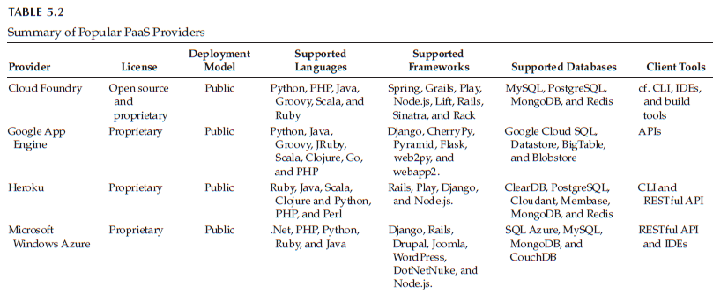

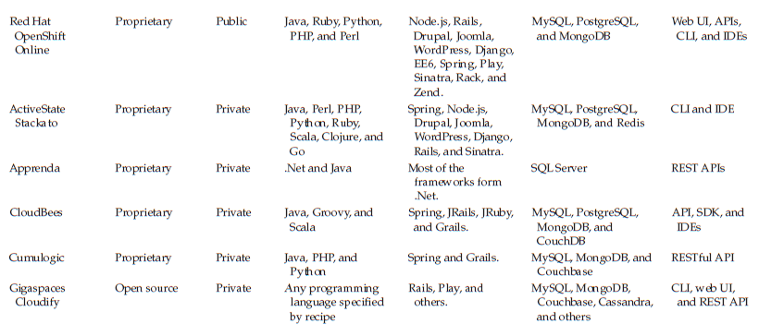

AWS Elastic Beanstalk (EB)

Definition and Conceptual Overview
AWS Elastic Beanstalk is an easy-to-use Platform-as-a-Service (PaaS) for deploying and scaling web applications and services developed with Java, .NET, PHP, Node.js, Python, Ruby, Go, and Docker on familiar servers such as Apache, Nginx, Passenger, and IIS.
It is positioned as an orchestration service. While AWS CloudFormation requires you to define every resource manually via templates, Elastic Beanstalk automatically handles the "heavy lifting" of deployment—from capacity provisioning and load balancing to auto-scaling and health monitoring.
- Core Components of the Infrastructure
- Application: This is the top-level logical folder for your project. It contains all the versions of your code and the environments where they run.
- Application Version: This refers to a specific, labeled iteration of your deployable code. Typically, this is a source bundle stored in Amazon S3 (e.g., a Java .war file or a Python .zip file). You can have many versions, allowing for easy rollbacks.
- Environment: This is the actual infrastructure running a specific version of your application. An environment is composed of AWS resources like EC2 instances, an Auto Scaling group, and a Load Balancer.
- Environment Tier: Web Server Tier: Standard web applications that handle HTTP/HTTPS requests.
  - Worker Tier: Specialized environments that pull tasks from an Amazon SQS queue to handle background processing (e.g., image processing or email blasting).
2. The Architectural Workflow
The power of Elastic Beanstalk lies in its automated provisioning. When you deploy an application, the following architectural flow occurs:
- Code Upload: The user uploads a source bundle via the AWS Management Console, CLI, or IDE.
- Resource Provisioning: EB creates an Auto Scaling Group to manage the fleet of EC2 instances.
- Traffic Management: An Elastic Load Balancer (ELB) is positioned in front of the instances to distribute incoming traffic evenly, ensuring high availability.
- Host Manager: A small software component called the "Host Manager" runs on each EC2 instance. It is responsible for downloading the code, configuring the local server (like Apache or Tomcat), and reporting health metrics back to the EB dashboard.
- Storage: The application files and optional server logs are stored in an Amazon S3 bucket automatically created by the service.

2.1 Advanced Configuration: .ebextensions
These are configuration files written in YAML or JSON that you place in a folder named .ebextensions in the root of your source code.
They allow you to:
- Install additional software packages on the EC2 instances.
- Create additional AWS resources (like an ElastiCache cluster) that live within the environment.
- Modify server configurations (e.g., changing PHP.ini settings or Nginx rules).

2.2 Management and Monitoring
Elastic Beanstalk provides a unified interface for monitoring the "Health" of your application.
- Health Monitoring: It uses a color-coded system (Green for healthy, Yellow for warning, Red for critical) based on web server logs and system metrics (CPU utilization, latency).
- Managed Updates: You can configure EB to automatically apply platform updates (patches to the operating system or application server) during a specified maintenance window to ensure security.
- Logging: It integrates with Amazon CloudWatch for log aggregation and monitoring. You can request "Tail Logs" (the last 100 lines) or "Full Logs" directly from the console without SSHing into instances.

2.3 Key Advantages
- Speed: Go from code to a live URL in minutes.
- Developer Focus: Eliminates the need for deep "SysAdmin" knowledge to get started.
- Full Control: Unlike many PaaS competitors, you retain full "root" access to the underlying EC2 instances and can modify the infrastructure at any time.
- Cost-Effective: There is no separate fee for using Elastic Beanstalk; you only pay for the EC2, S3, and Load Balancing resources you consume.

Database as a Service (DBaaS) Amazon DynamoDB

Definition
Database as a Service (DBaaS) is a cloud service model under Platform as a Service (PaaS) where the cloud provider delivers a fully managed database platform. Users can create and use databases without managing servers, OS, storage, patching, backups, or scaling.
Amazon DynamoDB is a fully managed, multiregional, multimaster, durable NoSQL database service provided by AWS. It is designed to provide seamless scalability with single-digit millisecond latency at any scale. Unlike traditional relational databases (RDBMS), DynamoDB is a key-value and document database that does not require a fixed schema, making it ideal for high-scale web applications, gaming, and IoT.

Using Amazon DynamoDB as an example:
- It is a fully managed NoSQL database provided by Amazon Web Services.
- Users only create tables and store data.
- AWS handles:
  - Infrastructure provisioning
  - Automatic scaling
  - Backup and restore
  - Patching and maintenance
  - High availability and replication

This fits the PaaS/DBaaS model because the user focuses only on data and application logic, while the provider manages the entire database platform.

Fundamental Data Structures
To understand DynamoDB, one must understand its hierarchical data organization:
- Tables: Similar to a table in RDBMS, but without a fixed schema.
- Items: Equivalent to a "row" or "record." Each item is a collection of attributes. There is a 400 KB limit per item.
- Attributes: Similar to "fields" or "columns." While RDBMS requires every row to have the same columns, DynamoDB items can have different attributes (schemaless), except for the Primary Key.

Primary Keys and Partitioning
The Primary Key is the only required attribute for every item in a table. It determines how data is distributed across physical partitions. There are two types:
- Partition Key (Simple Primary Key): Composed of a single attribute (e.g., UserID). DynamoDB uses an internal hash function to determine the physical partition where the data is stored.
- Composite Primary Key (Partition Key + Sort Key): Composed of two attributes (e.g., UserID and Timestamp). All items with the same Partition Key are stored together, sorted by the Sort Key. This allows for powerful "Range" queries.

Throughput and Capacity Modes
DynamoDB offers two models for managing database performance and cost:
- Provisioned Capacity Mode: You specify the number of reads and writes per second that you expect your application to require. This is measured in Read Capacity Units (RCUs) and Write Capacity Units (WCUs). It is cost-effective for predictable workloads.
- On-Demand Capacity Mode: DynamoDB automatically scales up or down based on traffic. You pay per request rather than per hour of provisioned capacity. This is ideal for unpredictable or "spiky" workloads.

Secondary Indexes
To query data using attributes other than the Primary Key, DynamoDB uses indexes. There are two types:
- Local Secondary Index (LSI): Shares the same Partition Key as the base table but uses a different Sort Key. It must be created at the time of table creation and cannot be added later.
- Global Secondary Index (GSI): Can have a completely different Partition Key and Sort Key from the base table. It can be created or deleted at any time.

Advanced Features and Performance
For a high-scoring answer, mention these specialized capabilities:
- DynamoDB Accelerator (DAX): A fully managed, highly available, in-memory cache for DynamoDB that delivers up to a 10x performance improvement—from milliseconds to microseconds.
- DynamoDB Streams: A time-ordered sequence of item-level changes (Insert, Update, Delete) in a table. It is often used to trigger AWS Lambda functions for real-time processing.
- Time to Live (TTL): Allows you to define a specific timestamp for items to be automatically deleted from the table, helping manage storage costs and data lifecycle automatically.
- Global Tables: Provides a fully managed solution for deploying a multi-region, multi-active database. Data is replicated across AWS regions automatically with a "last writer wins" conflict resolution policy.

Benefits
- Serverless: No servers to provision, patch, or manage.
- Scalability: Scales horizontally to support massive amounts of data and hundreds of millions of requests per second.
- Security: Data is encrypted at rest by default using AWS Key Management Service (KMS).
- High Availability: Data is automatically replicated across three Availability Zones (AZs) within a single region.

Software as a service
What is SaaS?
SaaS is a software distribution model where applications are hosted by a third-party provider and made available to customers over the internet.
- Hosting: The provider manages the entire "stack"—from the hardware and operating system to the application code itself.
- Access: Users access the software via a web browser (e.g., Chrome, Firefox) or a thin-client app.
- Payment: Moves from a Perpetual License (one-time buy) to a Subscription Model (Pay-as-you-go).
.How Does SaaS Work?
Centralized Hosting: The provider hosts the application on their own servers (or on an IaaS like AWS). They handle all maintenance, security patches, and hardware refreshes.
- Multi-tenant Architecture: A single "instance" (one version of the code) serves multiple customers.
  - Analogy: It’s like an Apartment Building. All residents share the same infrastructure (plumbing, lobby, elevator) but each has their own private, secure living space (data isolation).
- Automatic Delivery: Updates are pushed by the provider. When you log in, you are automatically using the most current version without needing to download an "Update.exe" file.

Key Components of SaaS

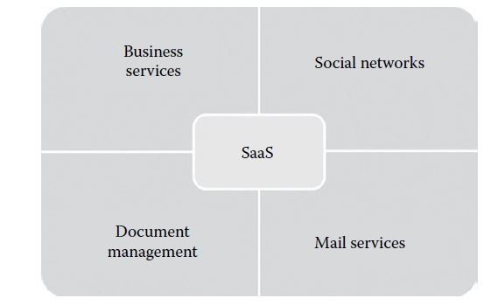
SaaS providers typically categorize their offerings into four major functional components:
I. Business Services
These are specialized tools designed to automate corporate operations. They are highly attractive to startups because they eliminate the need for an in-house IT department to manage complex databases.
- ERP (Enterprise Resource Planning): Managing the entire business process (Finance, Supply Chain).
- CRM (Customer Relationship Management): Tracking sales leads and customer data.
- Billing & HR: Managing payroll, employee records, and invoicing.
- Example:Salesforce (CRM) or Zoho (Business Suite).
II. Social Networks
Social media platforms use SaaS because their user base grows exponentially and unpredictably. Cloud-based SaaS allows them to handle millions of simultaneous logins without crashing.
- Variable Load: The system automatically scales as more users sign up or log in during peak hours.
- Example:Facebook, LinkedIn, or X (Twitter).
III. Document Management
Enterprises deal with massive amounts of electronic documentation. SaaS providers offer tools to create, track, and collaborate on these files in real-time.
- Collaboration: Multiple users can edit the same document simultaneously from different parts of the world.
- Example:Google Docs, Dropbox, or Microsoft 365.
IV. Mail Services
Email is the most common SaaS application. Because email volume is unpredictable, hosting it in the cloud ensures that users never run out of storage space or experience downtime.
- Accessibility: Users can check mail from any device without configuring complex POP3/IMAP settings locally.
- Example:Gmail, https://www.google.com/search?q=Outlook.com.

Characteristics of SaaS
Software as a Service (SaaS) is a cloud-based software distribution model where applications are hosted by a third-party provider and made available to customers over the internet. This model offers several distinct characteristics that differentiate it from traditional software deployment methods. Below are the key characteristics of SaaS:
What makes a SaaS application unique compared to traditional "Installed" software? These seven characteristics define the model:
1. One-to-Many Model
In traditional software, every user has their own unique copy of a program. In SaaS, a single instance (one version of the code) of the application serves multiple "tenants" or customers.
When the developer wants to add a feature or fix a bug, they only have to update the code once in the central cloud. Every single user across the globe gets that update instantly.
2. Web Access
SaaS applications are "Browser-Native." This means the primary way to interact with the software is through a standard web browser (Chrome, Safari, Firefox).
It eliminates "Location Dependency." As long as a device is connected to the internet, a student or employee can access their work from a library, a cafe, or a home office without needing to carry a specific "work laptop."
3. Centralized Management
The provider manages everything from a central location. This includes the database, the server hardware, and the software versioning.
It ensures Version Consistency. In a large company, you never have the problem where "User A" is on Version 1.0 and "User B" is on Version 2.0. Everyone is always synchronized on the most recent, secure version.
4. Multidevice Support
SaaS is built to be cross-platform. The interface is designed to adapt to different screen sizes and operating systems (Windows, macOS, iOS, Android).
It supports the "Bring Your Own Device" (BYOD) trend. A user can start a task on a desktop computer, continue it on a tablet during a commute, and check the status on a smartphone.
5. Better Scalability
SaaS applications sit on top of Infrastructure as a Service (IaaS). They use Dynamic Scaling—the ability to automatically request more CPU power or RAM from the cloud provider when traffic increases.
Even if a million new users sign up in one day, the application won't crash. It "stretches" to meet the demand.
6. High Availability
SaaS providers implement "Redundancy." This means they have copies of your data and the application running in multiple different geographic data centers.
Most SaaS vendors guarantee 99.99% uptime. If one data center experiences a power outage or a natural disaster, the system automatically flips to a backup center so the user experiences zero downtime.
7. API Integration
SaaS services are built to be "Modular." They use Standard APIs (Application Programming Interfaces) to talk to other software.
It allows for a "Best-of-Breed" strategy. A company can use one SaaS for their Email (Gmail), another for their CRM (Salesforce), and a third for their Team Chat (Slack), and link them all together so data flows between them automatically.

SaaS Suitability
1. On-demand Software- Occasionally used tools.
Traditional software requires you to buy a "Perpetual License" (a large upfront cost). If you only need a video editor for one month, buying a $500 license is a poor Return on Investment (ROI). With SaaS, you subscribe for $20 for one month and cancel when the project is done.
2. Software for Start-up Companies--Businesses with limited initial capital.
To run traditional software, a startup would need to buy high-end servers and hire IT staff to maintain them. SaaS requires zero hardware investment. A startup can run "Enterprise-grade" software for a small monthly fee, allowing them to spend their capital on growth instead of infrastructure.
3. Software Compatible with Multiple Devices--Apps that require high mobility (e.g., Word processors, Email).
Some tasks require "Continuity." Since the data is stored in the cloud (not the device), the user has the freedom to switch hardware without losing their progress.
4. Software with Varying Loads---Applications with "Spiky" traffic (e.g., Social media, E-commerce sites during a sale).
It is very difficult to predict the load on a social networking site. If you use traditional hardware, you have to buy enough servers for the maximum possible load, which sit idle most of the time. SaaS handles these "spikes" efficiently by scaling resources only when they are needed.

Pros and Cons of SaaS
Benefits of SaaS
The benefits of SaaS focus on cost-efficiency, speed, and operational simplicity.
- Significant Cost Savings (Shift from CapEx to OpEx):
No Hardware Investment: Traditional software requires high-end servers and storage. SaaS removes this "Capital Expenditure" (CapEx).
Subscription Pricing: Users pay a predictable monthly or yearly fee ("Operating Expenditure" or OpEx), making enterprise-grade software affordable for startups and small businesses.
Reduced IT Staffing: Since the provider manages the backend, companies don't need a large team of specialized database or system administrators.
- Rapid Deployment and Accessibility:
Instant Provisioning: Unlike traditional software that takes weeks to install and configure across a company, a SaaS account can be activated in minutes.
Universal Access: Because it is web-based, employees can work from anywhere (office, home, or traveling) using any device with an internet connection.
- Seamless Scalability and Flexibility:
On-Demand Resources: If a company grows from 10 to 1,000 employees, they simply adjust their subscription. The underlying cloud infrastructure scales automatically to handle the new load.
Low Commitment: Organizations can test a software tool for a month; if it doesn't provide a good Return on Investment (ROI), they can cancel the subscription without being stuck with expensive permanent licenses.
- Automated Maintenance and Updates:
Zero-Touch Updates: Security patches, bug fixes, and new features are rolled out by the provider. Users always log into the most "up-to-date" version.
Continuous Improvement: Providers constantly update the software to stay competitive, giving users access to the latest technology without manual intervention.
- High Availability and Disaster Recovery:
Data Redundancy: SaaS providers store data in multiple geographically dispersed data centers. If one center fails, another takes over.
Built-in Backups: Most SaaS platforms include automated backup services, ensuring data is not lost even if a user's local computer crashes.

2. Cons (Disadvantages) of SaaS
The drawbacks of SaaS primarily involve security, dependency, and performance.
- Security and Data Privacy Concerns:
Third-Party Storage: Sensitive company data is stored on the provider's servers. If the provider’s security is breached, the user's data is at risk.
Multi-tenancy Risks: Since multiple customers share the same application instance, there is a theoretical (though rare) risk of data leakage between "tenants."
- Dependency on Internet Connectivity:
No Internet = No Work: Unlike "on-premise" software that works offline, SaaS is completely unreachable during an internet outage.
Latency Issues: If the user’s internet is slow, the software will lag, leading to a poor user experience and decreased productivity.
- Loss of Control and Customization:
Vendor Lock-in: Migrating data away from a SaaS provider to a different platform can be extremely difficult and expensive (data portability issues).
Rigid Feature Sets: Because SaaS is a "one-to-many" model, you cannot ask the provider to change the core code just for your company. You must adapt your business processes to fit the software, not the other way around.
Forced Updates: Users cannot choose to stay on an older version of the software. If a provider changes the user interface in a way you dislike, you are forced to accept it.
- Performance and Integration Challenges:
API Limits: While SaaS apps offer APIs, they may not integrate perfectly with your existing legacy (old) in-house software.
Data Transfer Speeds: Syncing massive amounts of data between a local office and a cloud-based SaaS application can be slower than using a local area network (LAN).

Summary of SaaS providers
There are many SaaS providers who provide SaaS services such as ERP,
CRM, billing, document management, and mail services. Table 5.3 gives a
summary of popular SaaS vendors in the market
